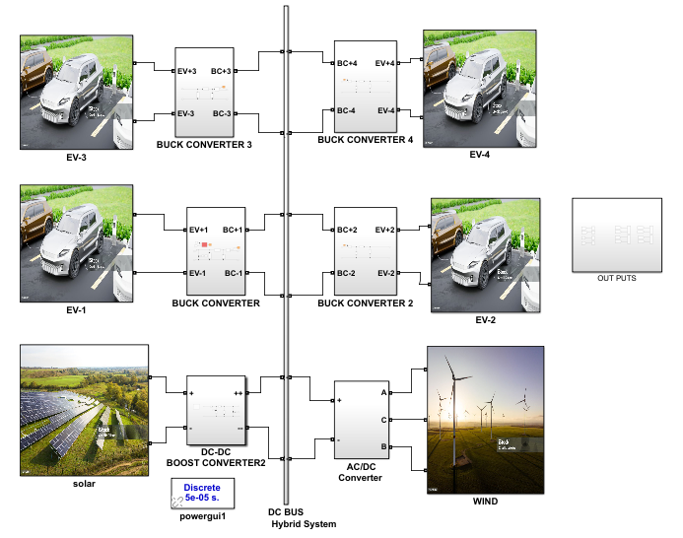
Fig 1 Simulation Diagram of proposed System.
Figure 1 illustrates the simulation diagram of the proposed system, which integrates a hybrid power generation system comprising both solar and wind energy sources for charging electric vehicles.
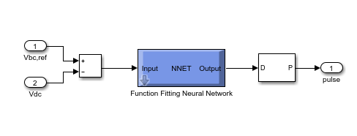
Fig 2 Buck converter Controller with ANN Control.
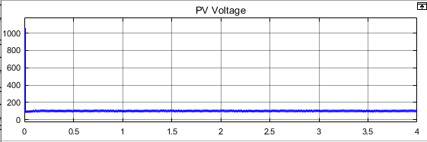
3(a) Solar Out Put
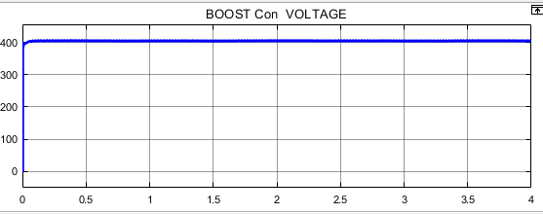
3(b) Boost converters Out Put
Fig. 3. Output voltage of the utilized boost converter and PV System
Fig. 3, the employed boost converter step up the voltage from 100V to 400V in the proposed DC fast charging station
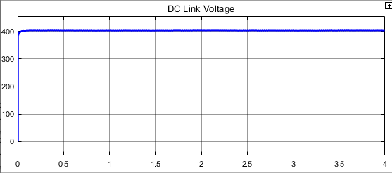
4(a) DC link Voltage
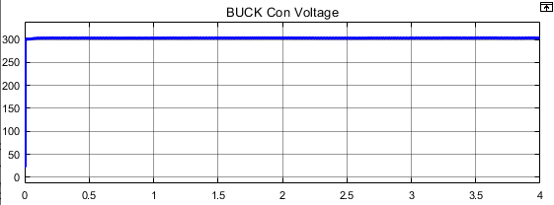
4(b) Buck Converter Voltage
Fig. 4. Output voltage of the utilized buck converter And Dc link Voltage
Fig. 4 shows the output voltage of the buck converter which should be equal to the needed voltage of the EV batteries.
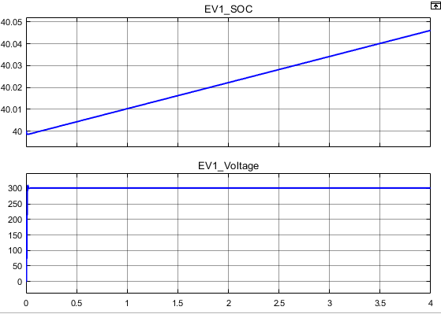
Fig5 EV1 Out Puts

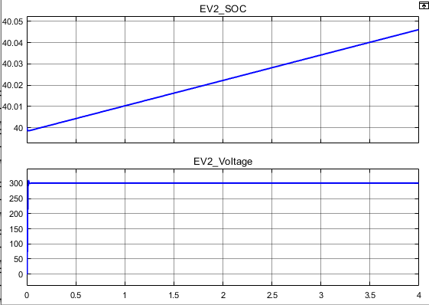
Fig6 EV2 Out Puts
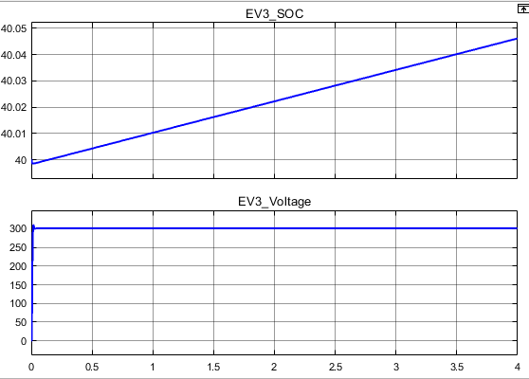
Fig7 EV3 Out Puts
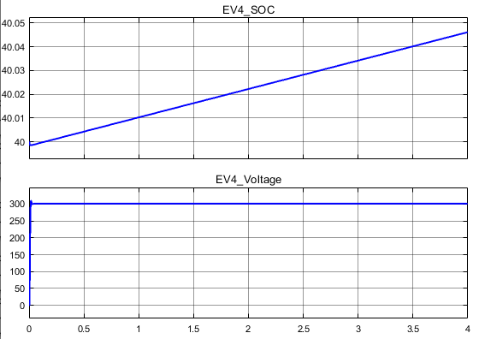
Fig 8 EV4 Out Puts

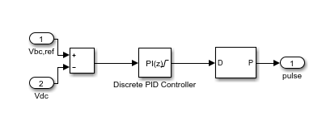
Fig 9 Buck converter Controller with PI Control.
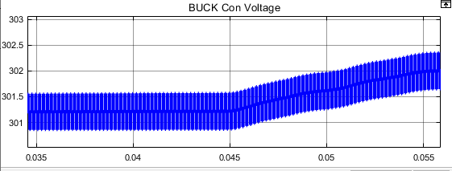
Fig 10 Zoomed results of Electrical Vehicle Battery Voltage with Buck converter Controlled by PI Controller
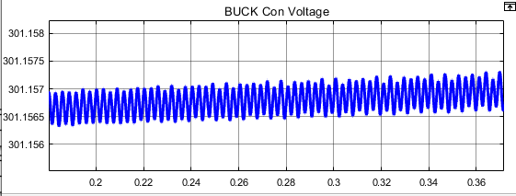
Fig 11 Zoomed results of Electrical Vehicle Battery Voltage with Buck converter Controlled by ANN Controller
Figures 10 and 11 illustrate the zoomed-in results of an Electric Vehicle (EV) battery voltage controlled by a Buck converter using both a PI Controller and an ANN Controller. Observations indicate that when the Buck converter is controlled by the PI Controller, the output voltage of the EV exhibits significant ripple content and more disturbed outputs. In contrast, utilizing the ANN Controller for the Buck converter results in a much smoother output voltage with minimal ripple. The reduced ripple content and smoother voltage levels achieved with the ANN Controller enhance battery performance and longevity. Excessive ripple and disturbed voltage outputs can lead to rapid battery degradation. Thus, the ANN Controller provides superior performance compared to the PI Controller, ensuring a more stable and reliable power supply for EV batteries.

